@ROOT NTP Server

apt-get install ntp

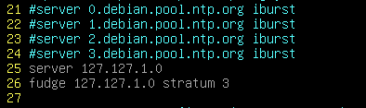

systemctl restart ntp

@Client ( hq, branch, client1,2, ca,

# apt-get install ntpdate

# vim /etc/crontab

